DEVELOPMENT PLAN:

Planned Development - Mixed Use (PD-M) District

Woodson Mixed-Use Development

# GENERAL PURPOSE AND DESCRIPTION

The Woodson Mixed-Use Development Plan is intended to guide land-use planning and development of the subject property. The purpose of this Planned Development – Mixed Use (PD-M) District is to facilitate the development of the highest and best use of the property, to strengthen the neighborhood economy, and to promote the general welfare of the community in accordance with the guiding principles of the Midtown Area Plan.

The project is located within the North of Northgate Experience District, which the Midtown Area Plan designates as a gateway between Bryan and College Station that capitalizes on the services and amenities offered by the Union Hill Experience District to the north and Texas A&M University to the south. The proposed project is intended to conform to the aligning principles recommended for this Experience District by the Midtown Area Plan by:

* incorporating the student experience while addressing on-street parking issues,
* improving neighborhood amenities by adding small-format neighborhood commercial development, and
* concentrating higher-density development along the pedestrian corridor of College Main Street to encourage a pedestrian-oriented environment.

This new development will support the walkable environment by locating the proposed buildings close to the street and consolidating off-street parking into a shared parking lot located behind the buildings. Communal greenspace and improved sidewalks that incorporate existing mature oak trees will also be key features of the neighborhood development.

The development plan will incorporate a mix of commercial and residential uses wherein multifamily residential, small-format retail, and office space are blended within the existing neighborhood to enhance the streetscape. These neighborhood commercial facilities will supply daily necessities to the community residents through an easy-to-access development featuring communal plazas.

Additionally, the proposed development will primarily use the city-approved Walk-up pattern buildings as a basis for architectural design to ensure that it remains architecturally compatible the rest of the locality and wider Midtown Area. Development of the proposed site will also adhere to tree preservation best practices in order to maintain a familiar and aesthetically pleasing streetscape.

# SECTION 1: PERMITTED LAND USES

The following range of land uses shall be permitted by right in this PD-M District:

* Midtown Pattern—Walkup two-story (MP-W2)
* Midtown Pattern—Walkup three-story (MP-W3)
* Multifamily dwelling
* Live/Work Units
* Accessory/incidental uses to the main use
* Temporary structures for uses incidental to construction on the premises, which said buildings shall be removed upon the completion or abandonment of construction work.

The following land uses shall be permitted by right when limited to 3,000 square feet or less per building, and only when located on the ground floor within 265 feet of College Main Street:

* Office, professional and general administrative
* Retail stores and shops (retail services)
* Neighborhood services
* Personal service shop or custom personal services
* Fitness center
* Restaurant, cafeteria

# SECTION 2: DEVELOPMENT STANDARDS

# LOT AREA, HEIGHT, AND SETBACK REQUIREMENTS

Physical development in the PD-M District shall comply with development standards and limitations of the City of Bryan Code of Ordinances that generally apply to the C-2 Retail District.  The following additional standards shall be applicable:

* The minimum front building setback shall be 5 feet.
* The minimum side building setback shall be 5 feet.
* The minimum rear building setback shall be 5 feet.
* The maximum impervious cover shall be limited to 80%.
* The minimum lot depth shall be 100 feet.
* The maximum height of any one building shall be limited to 45 feet OR 4 stories, whichever is greater.
* Where these PD-M development standards are silent, the standards for C-2 properties shall apply.

# PARKING REQUIREMENTS

1. Woodson Mixed-Use Development is located in the “North of Northgate” Experience District per the Midtown Area Plan, and it is also within the designated boundary of the Midtown High-Density (MT-HD) zoning overlay. As such, the development has been designed with attention to accommodate the specific characteristics of student-oriented housing where many tenants without vehicles choose to reside due to the walk/bike proximity to the Texas A&M campus as well as other popular destinations in the immediate vicinity. Once constructed, the development will follow a similar pattern of attracting and incentivizing tenants that either do not have or do not bring vehicles to the development by offering reduced rent, reserved parking, and accommodation for shared-ride and other modes of transportation, thus alleviating any concerns of on-street parking or increased traffic concerns in the area.The following section provides additional parking requirements that are not included within the City of Bryan’s zoning code, Section 62-297.
2. Minimum parking.
   1. Residential: Three parking spaces per four bedrooms (0.75 parking ratio).
   2. Non-Residential: One parking space per 375 square feet of gross floor area of commercial space.
3. Parking Reduction. On a site plan, where a developer provides for alternative modes of transportation or is in range of specific existing transportation, the total off-street parking requirement for the project shall be reduced as follows and calculated in the off-street parking analysis on the site plan:
   1. 2 spaces per each dedicated ride-sharing parking space. Credit will be applied up to a maximum of 2 ride-sharing parking spaces per 25 bedrooms. Ride-sharing parking spaces shall be designated with signs and enforceable by towing.
   2. 1 space per every 6 bicycle parking spaces. Credit will be applied up to a maximum of 12 bicycle parking spaces. Bicycle parking spaces shall have racks to which bicycles can be locked.
   3. 1 space per every 6 scooter parking spaces. Credit will be applied up to a maximum of 12 scooter parking spaces.
   4. 1 space if site is located along a public transit route and within 1,000 feet of a fixed transit stop, measured along sidewalks. Credit will be applied for each fixed transit stop within 1,000 feet of the site.
   5. 1 space if site is located within 1,000 feet of a public parking lot or garage, measured along sidewalks.
4. When constructed along Woodson Drive, on-street parking spaces shall be located within the existing right-of-way and incorporate improved curb extensions (bulb-outs) that will fully contain parked vehicles beyond the existing curbline and outside the traffic flow of Woodson Drive. These on-street parking spaces shall be counted toward the required parking minimums and subject to the following standards:
   1. On-street parking shall be prohibited in the following places as described by the Texas Transportation Code:
      1. In front of a public or private driveway;
      2. Within 15 feet of a fire hydrant;
      3. Within 20 feet of a crosswalk at a public intersection
      4. Within 30 feet on the approach to a flashing signal, stop sign, yield sign, or traffic control signal located at the side of a public roadway;
      5. Within 50 feet of a railroad crossing;
      6. Where an official sign prohibits parking.
   2. On-street parking area design shall comply with the minimum standards set forth in the Parking Area Design section for commercial Parking and Circulation regulations found in the, Land and Site Development Chapter of the Bryan Code of Ordinances, except that 90 degree angled parking is prohibited and the minimum width of the remaining two-way travel lane shall be 20 feet. Parking area design shall be consistent within a block and should be consistent between adjacent blocks.
   3. Pavement markings shall be required and shall comply with the Striping and marking requirements found in Article VI. – Access and Off-Street Parking, Section 62-297(c).
   4. Where a bike lane exists or is designated, there shall be no adjacent vehicle parking unless there is an alternative path and a method of directing cyclists to an adjacent sidewalk.
   5. Only on-street parking spaces located entirely in front of a subject property may be claimed towards the total off-street parking requirements for a project. There shall be no on-street parking along College Main Street.
5. Parking location. Off-street parking shall not be constructed between a building and the street a building is oriented towards. Off-street parking spaces may be located to the side or to the rear of the adjacent structure.
6. Driveway width. Minimum driveway width is 23’. Maximum curb cut radius is 20’.

**LANDSCAPING**

1. Landscaping.
   1. Landscaped areas along the front, sides, and rear of the property shall comprise of a minimum of 15% of the total developed area (building site). Preserved existing tree canopy shall count towards the 15% landscaped area requirement Landscaping shall meet the requirements of the Bryan Code of Ordinances “Section 62-429-Landscape Requirements” excluding the requirements outlined in paragraph “B. Parking Areas”.
   2. Newly installed landscaping shall incorporate the use of an underground irrigation system where necessary. All newly installed landscaping, including trees, shrubs and ground cover, shall be selected from the City of Bryan’s approved list.
   3. Existing mature trees will be preserved wherever practicable. Mature trees with trunk diameter over four and one-half inches in caliper shall count as 400 square feet towards the landscaped area requirement, with an incremental 100 square feet for each additional one inch in caliper, not to exceed 1,000 square feet, if they are protected during construction according to the tree protection detail below:

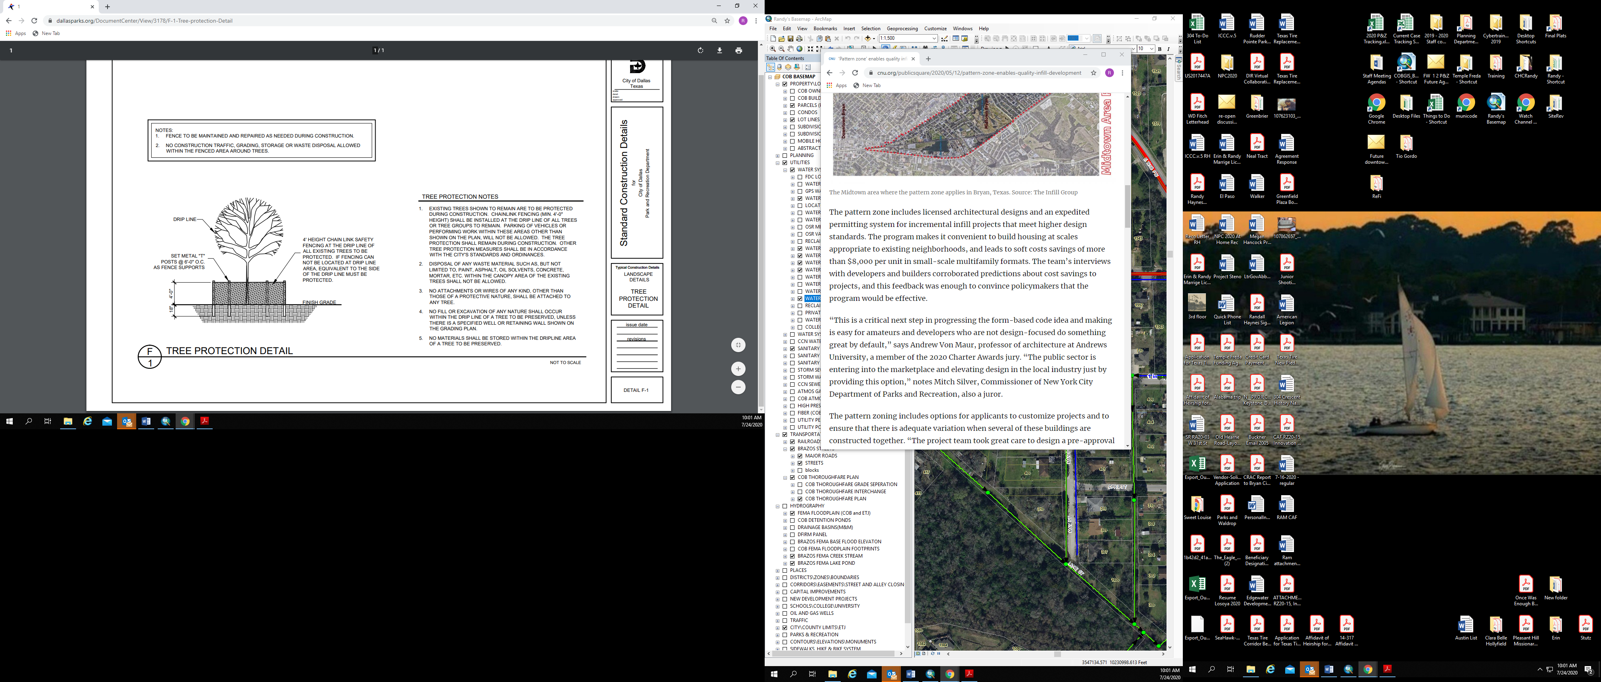

1. Street Trees. Tree placement shall be in accordance with the approved Midtown Area Plan as follows:
   1. One street tree per 30’ of lot width is required, round up normally.
   2. Trees shall be planted in the right-of-way between the curb and the sidewalk. If underground utilities or other conflicts prevent planting in that location, then they shall be planted within 4’ to 10’ of the sidewalk to provide shade and reduce future maintenance costs.
   3. Existing trees with a canopy that extends within 10’ of the sidewalk edge may be counted towards this requirement and shall be protected during construction according to the tree protection detail.

# SPECIAL REQUIREMENTS

1. Pedestrian facilities. A minimum 6-foot wide sidewalk shall be constructed along Woodson Drive in accordance with City standards and subject to the following:
   1. Sidewalks, where practicable, shall be routed around existing mature trees in order to facilitate preservation of existing treescape, which shall be protected during construction.
   2. Sidewalks may have changes in elevation at a driveway interface, which meets ADA standards.
   3. Each principal building shall have a clear and dedicated pedestrian-oriented route from the right-of-way to its primary entrance.
2. Trash and recycling. Containers shall be stored in a designated area to the rear of the buildings. A minimum of 2 dumpsters are required and may be co-located for aggregated service.
3. Utilities. Where electric facilities are installed, BTU has the right to install, operate, relocate, construct, reconstruct, add to, maintain, inspect, patrol, enlarge, repair, remove and replace said facilities upon, over, under, and across the property included in the PUE, and the right of ingress and egress on property adjacent to the PUE to access electric facilities.
4. Signage. Subject to separate approval according to City sign permit procedures, a monument sign shall be allowed on the property to be located within the building setback along College Main Street. The sign shall be a maximum of 10 feet long and a maximum of 6 feet tall measured from the finished ground elevation.  Additionally, one wall sign per lease space may be mounted vertically to the building not to exceed one square foot in sign area for each linear foot of that occupancy's building frontage up to a maximum of 30 square feet per lease space and/or 60 square feet per building. Where this PD is silent, the signage must be compliant with all other Retail District (C-2) sign regulations found in Chapter 98 of the Bryan Code of Ordinances. Signage is prohibited for residential uses with the exception of one home occupation sign as allowed per Chapter 98.
5. Screening and Buffers. A wood privacy fence, 6'- 0" in height minimum and fully opaque so as not to allow vehicles headlights to penetrate, shall be provided along the property lines that are adjacent to Residential use. Where practicable, the existing natural vegetation buffer long the rear of the property will be preserved in the area between the site improvements and wood privacy fence to be constructed. The development will not be screened from College Main Street nor from Woodson Drive.
6. Drainage. Drainage design and improvements shall be in accordance with the Bryan/College Station Unified Stormwater Design Guidelines.
   1. Drainage Report. A Drainage Report that fully documents the plan and facilities for managing storm flow of this development project will be required. This Drainage Report shall identify and address the issues related to development. These include, but are not limited to the attenuation of pre versus post developed flows (detention), erosion due to concentration of flows, and site to site drainage with adjacent properties. This will include the subject property, above-project areas, and along downstream conveyance area.
   2. Permitting. Coordination and permitting of stormwater matters must be addressed. This is to include any specialized coordination that has occurred or is planned with other entities (local, state, or federal). This may include agencies such as the Texas Commission for Environmental Quality, the US Army Corps of Engineers, the US Environmental Protection Agency, et al. Mention must be made of any permits, agreements, or understandings that pertain to the project.
   3. Stormwater Discharge. Where drainage easements and discharge are to drain across neighboring properties, it shall be the responsibility of the project owner/developer to ensure discharges are delivered at substantially the same flow characteristics and same location that existed pre-development. The project owner/developer is also responsible for receiving flows from Borderbrook Phase 1. A private drainage easement will be established for the proposed drainage facilities underneath the parking lot. The City may also require this private drainage easement to extend to the back line of Borderbrook Phase 1, then release the existing 25’ public drainage easement. This decision will be made once staff has had the opportunity to review the project design documents. In either case, the 25’ public utility easement will be retained by the City.